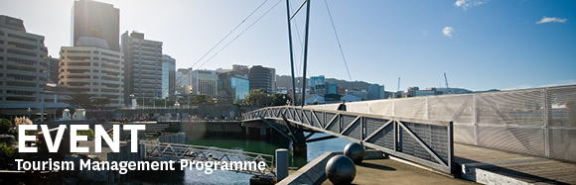

|  |  |  |  |  |  |  |  |  |  |  |
| --- | --- | --- | --- | --- | --- | --- | --- | --- | --- | --- |
| |  |  |  |  |  |  |  |  |  |  | | --- | --- | --- | --- | --- | --- | --- | --- | --- | --- | | |  | | --- | | The Tourism Management Group, part of the School of Management, Victoria Business School,  invites you to attend the following seminar: | |  | | **Walking on the Light Side:  Ventures into the mysterious world of ghost tourism** | | | Presenter: **Dr Jayne Krisjanous**  Senior Lecturer in the School of Marketing and International Business Victoria University of Wellington  **Wednesday 15th March**  **12.45 – 1.45pm**  **Boardroom, Level 12, Rutherford House**  **Pipitea Campus, Wellington**  Ghost tourism plays a significant part in the nightlife of urban areas all over the world. Although not conceived of as a mainstream tourist activity, and arguably comprised of experiences many tourists would prefer to avoid, it makes a valuable contribution to both cultural and tourism economies. Today ghost tourism is not just the domain of entrepreneurs with a penchant for the dramatic but also is beginning to be embraced by large established tourism enterprises, such as hotels and national heritage organisations.  In this seminar Jayne Krisjanous will present some of her research on ghost tourism that includes website analysis, interviews with ghost tour operators, and active participant observation in several countries. The role of ghost tourism within the broader spectrum of dark tourism will also be discussed.  **Author**  Dr Jayne Krisjanous is a Senior Lecturer in the School of Marketing and International Business at Victoria University of Wellington and is the school’s postgraduate programme director.  Her areas of research include healthcare marketing, historical research in marketing, consumer lifestyles, social marketing and dark tourism.  ALL WELCOME | | |  | | |  |   Any queries please Email: [tourism@vuw.ac.nz](mailto:tourism@vuw.ac.nz) |
|  |