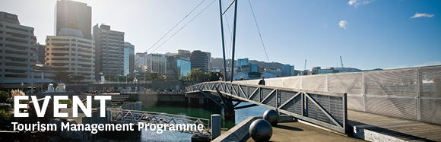

|  |  |  |  |  |  |  |  |  |  |  |
| --- | --- | --- | --- | --- | --- | --- | --- | --- | --- | --- |
| |  |  |  |  |  |  |  |  |  |  | | --- | --- | --- | --- | --- | --- | --- | --- | --- | --- | | |  | | --- | | The Tourism Management Group, part of the School of Management, Victoria Business School, invites you to attend the following seminar: | |  | | **The agony and ecstasy of operating NZ’s first integrated regional development agency** | | | Presenter: Stuart Trundle, CEO of the Venture Taranaki Trust  **Wednesday 9th September**  **12.30 - 1.30pm**  **Boardroom, Level 12, Rutherford House**  **Pipitea Campus, Wellington**  Stuart oversaw the formation of the first regional agency to combine the responsibilities of an economic development agency, a regional tourism organisation, a film commission and a major events attraction team.  He will give personal insights of the successes and failures from his experiences directing regional and national economic strategies in the UK, Poland, Romania and Taranaki whilst managing the creative tensions of multiple funding relationships with territorial local authorities, central government and the private sector.  Stuart Trundle is the chief executive of Venture Taranaki Trust, the regional development agency for Taranaki regarded as one of the leading models for economic development in New Zealand.  Stuart is also a board member for the Economic Development Centre at AUT, past chair of the Economic Development Association of New Zealand and a board member of the Bishop’s Action Foundation.  Prior to forming Venture Taranaki, Stuart was managing director of the largest Chamber of Commerce in the United Kingdom, an external examiner of the MBA programme at the University of Wolverhampton Business School and the course validator for the University of Central England’s Diploma in Management Studies.  Stuart’s work in the formation of regional economic development agencies in Poland and Romania was supported by the British Government and European Commission.  In October 2012 Stuart was awarded the New Plymouth District Mayoral Award for Business, presented in recognition of over 14 years commitment to economic development in the region. He is a past winner of the Vero Excellence in Business Support Award. | | |  | | |  |   Any queries please Email: [tourism@vuw.ac.nz](mailto:tourism@vuw.ac.nz) |
|  |