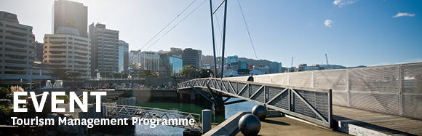

|  |  |  |  |  |  |  |  |  |  |  |  |
| --- | --- | --- | --- | --- | --- | --- | --- | --- | --- | --- | --- |
| |  |  |  |  |  |  |  |  |  |  |  | | --- | --- | --- | --- | --- | --- | --- | --- | --- | --- | --- | | |  | | --- | | The Tourism Management Group, part of the School of Management, Victoria Business School, invites you to attend the following seminar: | |  | | **The value of the cruise sector to NZ's economy and forecasts** | | | | Raewyn Tan, General Manager of Cruise New Zealand  **Wednesday 23rd September**  **12.30 - 1.30pm**  **Boardroom, Level 12, Rutherford House**  **Pipitea Campus, Wellington**  In the absence of official measurement and value, despite being the equivalent of New Zealand's 3rd largest inbound source of holiday arrivals, Cruise New Zealand undertakes these analyses on its own. This presentation will discuss the size and economic value of the cruise sector to New Zealand as published in Cruise New Zealand's recently released economic impact report for 14/15 cruise season, and will also outline forecasts and its influencing factors.  About the presenter:  Currently General Manager of Cruise New Zealand, Raewyn joined the sector in 2008 when she joined Tourism New Zealand in the then newly created role of Cruise Market Development Manager. Prior to that, she was in the international marketing team at Positively Wellington Tourism and was Research Fellow at Victoria University on the FRST-funded "Tourism Distribution Channels" project. Raewyn is passionate about the cruise sector and enjoys using her research and destination marketing skills in this lobbyist role at Cruise New Zealand.  . | | |  | | |  |   Any queries please Email: [tourism@vuw.ac.nz](mailto:tourism@vuw.ac.nz) |
|  |