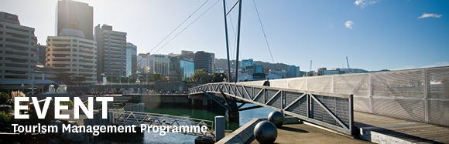

|  |  |  |  |  |  |  |  |  |  |  |  |
| --- | --- | --- | --- | --- | --- | --- | --- | --- | --- | --- | --- |
| |  |  |  |  |  |  |  |  |  |  |  | | --- | --- | --- | --- | --- | --- | --- | --- | --- | --- | --- | | |  | | --- | | The Tourism Management Group, part of the School of Management, Victoria Business School, invites you to attend the following seminar: | |  | | **The impact of life events on the tourism behaviour of senior citizens in  Freising, Germany** | | | | **Presenter: Dr Dominik Huber**  **Wednesday 21st October**  **12.30 - 1.30pm**  **Boardroom, Level 12, Rutherford House**  **Pipitea Campus, Wellington**  The senior market is a driving force in the tourism industry and one of the fastest growing market segments. Demographic changes, and the evolving travel routines of those people reaching senior age, suggest enormous potential for the tourism industry. Even though tourism scholars recognise the importance of this subject, seniors’ tourism behaviour remains a relatively under-researched topic in the field.  The underpinning rationale behind this thesis is that the life courses of seniors are shaped by meaningful transitions such as deteriorating physical health, changes in family structure and social roles. The aim of the thesis is to identify relevant life events, to investigate how they impact on seniors’ tourism behaviour and to get an in-depth understanding of the meanings behind this phenomenon.  The thesis is based on qualitative research and results in a senior tourism behaviour model which integrates leisure-constraints approaches and the fundamentals of ecological systems theory. The thesis demonstrates that life events operate on different constraint and facilitator levels, reflecting the complexity of their impact on tourism behaviour  **About the presenter**  Dominik Huber joined the Tourism Management Group at Victoria University in 2015 when he successfully applied for a contract lecturer position at the School of Management. He arrived in New Zealand in 2011 to start his PhD thesis at Auckland University of Technology with the title “The impact of life events on the tourism behaviour of senior citizens in Freising, Germany”. Dominik was awarded with the Vice Chancellor Scholarship and Graduate Assistantship Award at AUT and graduated in December 2014. Before Dominik moved to New Zealand he worked in different fields related to geography and tourism including urban planning, tourism and energy consulting and land surveying in Germany and Switzerland.  Any queries please email [tourism@vuw.ac.nz](mailto:tourism@vuw.ac.nz) | | |  | | |  | |
|  |