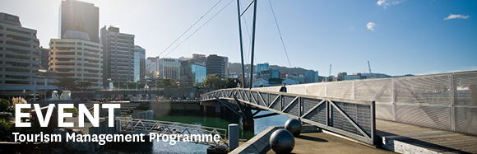

|  |  |  |  |  |  |  |  |  |
| --- | --- | --- | --- | --- | --- | --- | --- | --- |
| |  |  |  |  |  |  |  |  | | --- | --- | --- | --- | --- | --- | --- | --- | | |  | | --- | | The Tourism Management Group, invites you to attend the Master of Tourism Management progress presentations | |  | | **Wednesday 11th November**  **12.30 - 1.30pm**  **RH 1113, Level 11, Rutherford House**  **Pipitea Campus, Wellington**  **Distribution channels for Community-Based Tourism.**  **A case study of Banteay Chhmar CBT, Cambodia**  **Presenter: Sochea Nhem**  Abstract: Studies on Community-Based Tourism (CBT) have received attention in academic research not until 1985. Since then, such studies have been conducted and extended in many areas such as – participation, conservation, rural development and sustainability. Throughout rigorous literature review, it is suggested that a study on CBT distributional channels is under-investigated. In order to fill this research gap, this study is conducted to (1) investigate the complexity of CBT distribution channels from demand and supply sider perspectives, (2) examine the factors that affect CBT distribution channels and (3) find out the implications for CBT and how these help to improve selling CBT. This study employs case study approach which involves both qualitative and quantitative investigations. Interviews were conducted with twenty one key channels members while visitors who are visiting community are invited to complete the questionnaire.    **Chi Phat: An example of a success Community Based Tourism destination in Cambodia?** | | | **Presenter: Sophea Tieng**  Abstract: The community based tourism projects are driving force in the tourism industry in Cambodia. Even though tourism scholars recognise the importance of this subject, community success remains a relatively under-researched topic in the field.  The purpose of this thesis is to review the literature on community success in order to evaluate factors of success, to determine how different stakeholders perceive success for the Chi Phat CBET, to develop a conceptual framework of community based tourism important factors of success and to make recommendations for future community based tourism projects.  The thesis is based on qualitative research which interviewed 20 members of stakeholders of Chi Phat community. | | |  |   Any queries please email: [tourism@vuw.ac.nz](mailto:tourism@vuw.ac.nz) |
|  |