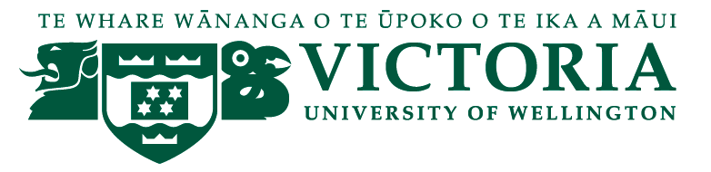

School of Management – Tourism Management Group

TOURISM MANAGEMENT SEMINAR

We are pleased to present the following seminar in our 2015 series:

Chris Roberts
Chief Executive
Tourism Industry Association New Zealand

Tourism 2025 – how are we tracking towards the $41 billion aspirational goal?

Wednesday 13th May, 12:30 - 13:30
followed by refreshments

Level 12, Boardroom, Rutherford House,23 Lambton Quay

It has been just over a year since the tourism industry released the Tourism 2025, a growth framework to unite New Zealand’s large and diverse tourism industry and ignite strong, aspirational economic growth. It is an industry commitment to growing value by working together, for the long-term benefit of New Zealand tourism and the wider economy.
What progress has been made in the last year and how is the industry demonstrating its commitment to achieving the $41 billion goal? TIA Chief Executive Chris Roberts will update what is happening at the macro and micro levels of the industry. www.tourism2025.org.nz

Chris joined TIA as Chief Executive in July 2014. As the only membership association representing all sectors of New Zealand’s $24 billion tourism industry, TIA works to influence, inform and align the industry, including driving forward implementation of the Tourism 2025 growth framework.
Previously Chris was a General Manager at Tourism New Zealand, with responsibility for government and stakeholder relations. He began his working life as a radio journalist. From senior editor roles at Radio New Zealand he moved to Parliament, which included working for the Minister of Tourism. His time in the Beehive was followed by a decade of senior corporate affairs roles in the energy sector before returning to tourism.

Any queries please contact tourism@vuw.ac.nz

