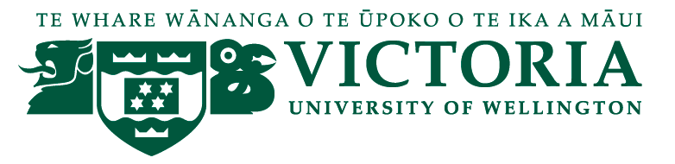

School of Management – Tourism Management Group

TOURISM MANAGEMENT SEMINAR

We are pleased to present the following seminar in our 2015 series:

How to develop a successful tourism product in a SME

Jeroen Jongejans, Dive! Tutukaka

Tuesday 14th July, 12:30 - 13:30
followed by refreshments

Level 12, Boardroom, Rutherford House,23 Lambton Quay

Jeroen Jongejans is a director of Dive! Tutukaka, an award-winning Northland business. He has been involved with the adventure tourism and outdoors industry for over 20 years and has also been on many boards, including Northland Tourism Development Group and Tourism Industry Association

The story of Dive! Tutukaka is an inspiring journey of a small adventure tourism company, coping with lack of money, fires on boats, sinking of ships, rough seas and political battles to become one of NZ's most successful SME's in the tourism Industry.
A journey through the last 30 years shows the evolution and evolvement of this business through hard work, determination, vision and sheer passion to cope with GFC, competition, seasonality, rough seas and fluctuating interest rates plus all the other obstacles that get in the way of a good night's sleep...
Innovation, adaptability, new product and re-inventing "the way we do business" coupled with passion and long term vision have shaped the way we move forward. A great journey from "the outside", a bit of a roller-coaster ride from the inside.....We still manage to give people a very memorable experience even if they go out on a rough day, for all the right reasons!
Jeroen Jongejans started this "dream journey" over 30 years ago after becoming inspired by "the underwater world”, its potential and the various pressures that deplete this magic resource.
He has taken this plight and push for increased awareness through a great number of channels, from Conservation Boards, District Councils, economic development boards, national politics, and various local and national tourism organizations.
The magic of the message has been the delivery of an inspiring experience for our clients, leading to increased awareness of the need to change the way we treat our Oceans.
And there is still so much more that needs to be done, and so many more adventures to be had!

Any queries please contact tourism@vuw.ac.nz

