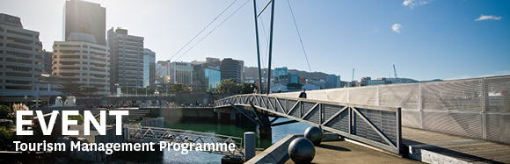

|  |  |  |  |  |  |  |  |  |  |  |
| --- | --- | --- | --- | --- | --- | --- | --- | --- | --- | --- |
| |  |  |  |  |  |  |  |  |  |  | | --- | --- | --- | --- | --- | --- | --- | --- | --- | --- | | |  | | --- | | The Tourism Management Group, part of the School of Management, Victoria Business School,  invites you to attend the following seminar: | |  | | **Rethinking tourism: GOOD Travel** | | | **Eliza Raymond** Co-Founder, GOOD Travel  **Friday 4th August**  **12.30 – 1.30pm**  **Boardroom, Level 12, Rutherford House**  **Pipitea Campus, Wellington**  The United Nations has declared 2017 as the International Year of Sustainable Tourism for Development. This is a unique opportunity to explore and highlight tourism’s potential as a catalyst for positive change. GOOD Travel is a Wellington-based social enterprise working globally to transform the travel industry into a force for GOOD. In this talk, Eliza will discuss the role of travellers in growing the demand for sustainable tourism. She will inspire you to re-think how you plan your next holiday and she will share practical tips for how to ensure that you have a positive social, economic and environmental impact when you travel.  **About the presenter**:  Eliza Raymond is the co-founder and director of operations at GOOD Travel. She holds a Master of Tourism from the University of Otago where she carried out her thesis looking at good practice in volunteer tourism. She is based in Wellington but her passion for sustainable and ethical travel takes her all around the world. She has worked on international development projects and tourism initiatives in Peru, Kiribati, Tuvalu, PNG, Guatemala, Chile, Nepal, South Africa and Kenya, but considers New Zealand home.  Good People. Good Places. GOOD Travel. [good-travel.org](http://good-travel.org/)  ALL WELCOME | | |  | | |  |   Any queries please email: [tourism@vuw.ac.nz](mailto:tourism@vuw.ac.nz) |
|  |