The Boundaries of European National Literatures

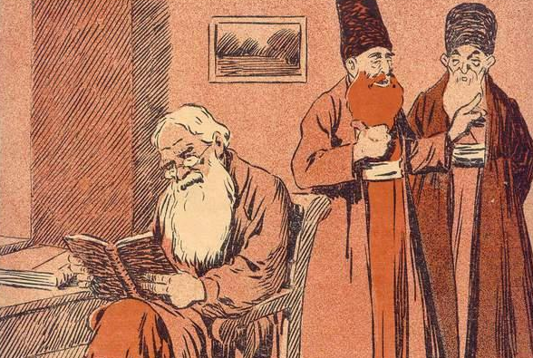

Patriots often express pride in national literature, claiming great works of art, or great novelists, as national icons. Literary figures may also imagine themselves promoting or embodying a national tradition. Whether novelists proclaim themselves national or are so proclaimed by others, however, the nation always has some boundary: as Benedict Anderson memorably put it, the nation is “inherently limited.” Even literatures whose boundaries are defined by a national language may have fuzzy boundaries, since the relationship of the national language to “dialectal” literature may be unclear. This conference explores the limits of the national language, either through an individual author, a literary circle or literary tradition, or in the minds of literary patriots.

The event will take place 25 August 2018 at the Kelburn Campus of Victoria University, Wellington, New Zealand. The event is free and open to the public. We regret that we have no money to support travel costs.

Send 100-word abstracts or queries by July 15 to:
Alexander Maxwell (alexander.maxwell@vuw.ac.nz)

