“The Politics of Categorizing Linguistic Varieties”
With growing scholarly interest in the process of categorization, it is timely to situate linguistic categorization within the broader history of ideas. This conference invites case studies in the politics of linguistic classification that place linguistic debates within the broader context of political struggles. The politics of linguistic categorization has many dimensions, its study can be pursued on several levels.
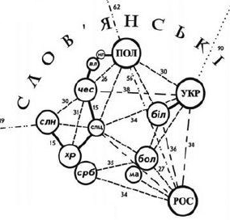
First, heated debate has often taken place as to how a given variety relates to others: the politics of cladistics and/or language trees is often hotly contested. Sumerian, for example, has inspired numerous claims, many of them outlandish, regarding its relationship to other languages; some apparently derive from the desire to claim a connection with the people who first invented literacy.
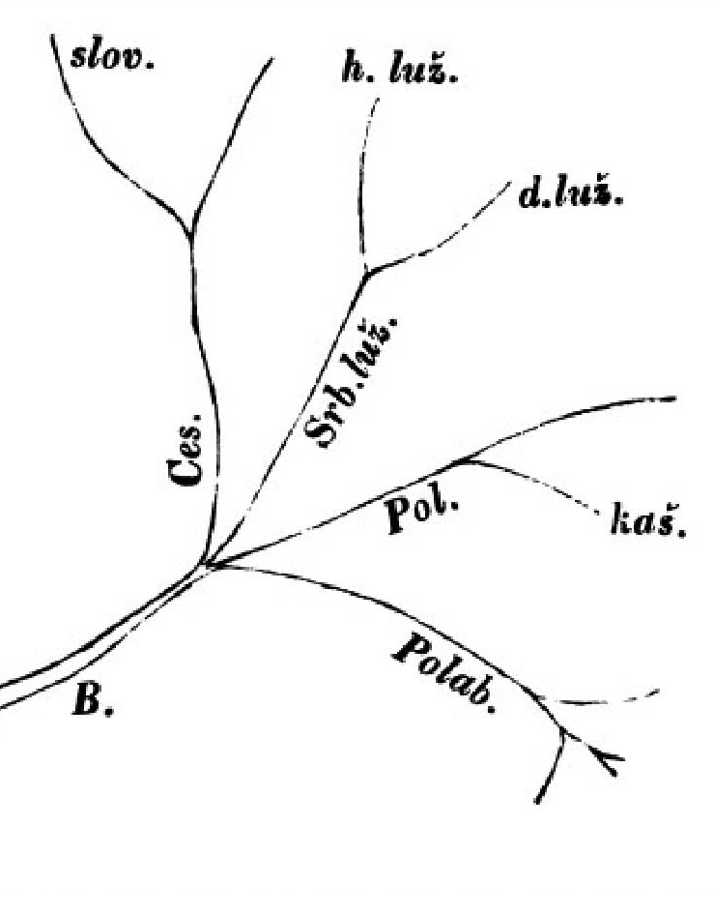
A second type of debate has centred on the status of a given variety as ‘language’ or ‘dialect.’ Such debates often serve as proxies for debates about official recognition: many states mandate certain rights and resources to minority communities with distinct ‘languages’; few states assign the same rights and resources to minority ‘dialects’, ‘idioms’, ‘accents’, and so forth.

Kelburn Campus of Victoria University
Old Kirk 406 (The Wood Seminar Room)
13 July 2019

The event is free and open to the public!
Questions? Email: Alexander.Maxwell@vuw.ac.nz
Participant Emails

Michael Erdman <Michael.Erdman@bl.uk>
Robert Greenberg <r.greenberg@auckland.ac.nz>
Tekabe Legesse Feleke <tekabelegesse.feleke@univr.it>
Camiel Hamans < hamans@telfort.nl>
Alexander Maxwell <alexander.maxwell@vuw.ac.nz>
Patrick Seán M^{c}Crea <pmccrea@tulane.edu>
Miriam Meyerhoff <miriam.meyerhoff@vuw.ac.nz>
Motoki Nomachi <mnomachi@gmail.com>
Michal Schwarz <schwarz@phil.muni.cz>
John Charles Smith <johncharles.smith@stcatz.ox.ac.uk>
James A. Walker <j.walker2@latrobe.edu.au>

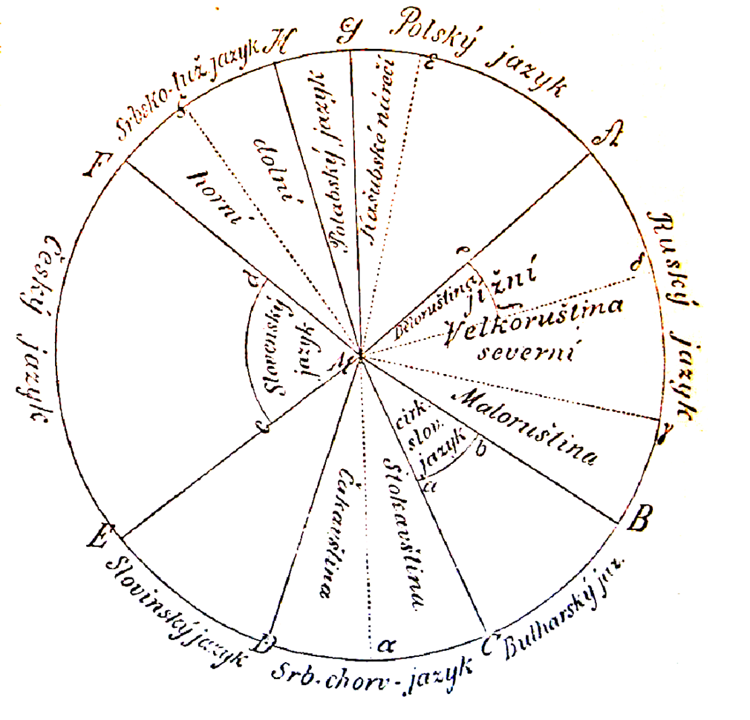
Conference schedule

9:00 Welcoming Remarks – The Politics of Linguistic Classification
Alexander Maxwell (Victoria University of Wellington)

9:30 Indigenous Lingusitic Knowledge
“Linguistic autonyms and the politics of documentation in Vanuatu“
Miriam Meyerhoff (Victoria University of Wellington)

“Turkic Typologies: Indigenous Linguistic Knowledge
and the Work of Bekir Çobanzadǝ”
Michael Erdman (British Library)

11:00 Linguistic Classification under Evolving Political Regimes
“Politicizing Language: Centuries of Tradition à la française”
Patrick Seán McCrea (Tulane University, New Orleans)
“Classifying the South Slavic Languages: The Case of the Goran Slavs”
Robert Greenberg (Auckland), Motoki Nomachi (Hokkaido University)

12:30 Lunch Break

1:30 The Politics of Large Ethno-Linguistic Categories
Disputing linguistic status beyond ‘Languages’ and ‘Dialects’:
Pavel Šafařík’s Taxonomy and Ľudovít Štúr’s Activism
Alexander Maxwell (Victoria University of Wellington)

“Mongol-oriented Taxons in Modern Science”
Michal Schwarz (Masaryk University, Czechia)

3:00 Definitions and Measurements
“A Variationist Perspective on Categorizing Linguistic Varieties” James A. Walker (La Trobe University)

“Linguistic Distance and Mutual Intelligibility among South Ethiosemitic Languages: A Combined Approach”
Tekabe Legesse Feleke (Università degli Studi di Verona)

4:30 State Ideologies and Linguistic Description
“The Moldovan Language Controversy and
the Manipulation of History”
John Charles Smith (University of Oxford, St Catherine’s College)

“Afrikaans as a testimony of origin”
Camiel Hamans (University of Amsterdam)

6:30 Conference dinner at the restaurant “Floriditas”
161 Cuba Street Tel: (04) 381-2212
Conference Abstracts

Michael Erdman (British Library)
“Turkic Typologies: Indigenous Linguistic Knowledge
and the Work of Bekir Çobanzadǝ”

The 19th-century scholarship of the Russo-German academic Vasily Radlov informed greatly early 20th-century Turkic linguistics. Aimed largely at European audiences, his work was quickly co-opted by Soviet authorities delineating national languages among the Turkic peoples. It was not, however, the only contemporaneous means of understanding the Turkic dialects; indigenous epistemologies were also in existence. In this paper, I explore such systems of knowledge through the work of the Crimean-Azeri linguist Bekir Çobanzadǝ. I uncover how changes in regimes altered and eliminated autochthonous Turkic input into the nomenclatures and practical applications of Turkic linguistics in the early 20th century.

Tekabe Legesse Feleke (Università degli Studi di Verona)
“Linguistic Distance and Mutual Intelligibility among South Ethiosemitic Languages: A Combined Approach”

The distance among closely related languages is usually measured from three dimensions: structural, functional and perceptual. The structural distance is determined by directly manipulating the phonetic, lexical, morphological and syntactic differences among the languages. The functional distance is measured based on the actual usage of the languages, e.g., mutual intelligibility and inter-lingual comprehensibility. The perceived distance is related to the subjective judgment of the speakers about the similarity/intelligibility between their native language and the neighboring languages. The present study examines the distance among 10 south Ethiosemitic languages (Soddo, Chaha, Silte, Muhur, Endegegn, Enemore, Gura, Mesqan, Gumer and Ezhiha) from these three perspectives. These languages are often called ‘Gurage languages’. They are among the endangered languages spoken in Ethiopia. The study intends to (1) examine the relationship among the three dimensions of linguistic distances; (2) re-examine previous classification of the languages; (3) determine the degree of mutual intelligibility among the languages, and (4) explore the effect of non-linguistic determinants (geographical distance and attitude) on the linguistic distance.

Robert Greenberg (University of Auckland)
Motoki Nomachi (Hokkaido University)
“Classifying the South Slavic Languages: The Case of the Goran Slavs“

This study tackles some of the controversies surrounding the classification of the South Slavic languages since the time of the national revivals among the Slavic peoples in the nineteenth century through modern times. Brief consideration is given to the debates around literary and standard languages and the place of dialects in the evolution of the contemporary standard languages. Special attention is given to the first joint Yugoslav state (1918-1939) when efforts were made to unify the language of Serbs, Croats, Montenegrins, and Macedonians under a unified Štokavian-based standard. This formulation changed in significant ways in Tito's Socialist Yugoslavia, where under the standard language ideology of “brotherhood and unity,” a joint Serbo-Croatian/Croato-Serbian language gained official status, and Macedonian became a separate literary and standard language. With the breakup of Yugoslavia in 1991, these classifications shifted again, and the joint language has fractured into four successor languages, Bosnian, Croatian, Montenegrin, and Serbian. On the margins of these speech territories other varieties have also been spoken about, such as the language of the Goran Slavs in parts of Kosovo and Macedonia, and that of the people in the area of Bunjevac in Vojvodina (Serbia).
In this context, the sociolinguistic controversies surrounding the Goran Slavs serve as a worthwhile case study. Firstly, from a purely linguistic viewpoint, their speech variety is characterized as a “Balkanized” South Slavic language occupying a transitional position between Serbian and Macedonian in a geographic region where there is not a sharp linguistic boundary separating one language from the other. Secondly, the Goran Slavs are multilingual. Within Kosovo, the Ekavian variety of the former Serbo-Croatian has served as their official sociolinguistically “high” language of communication, while the local Goran ethnolect functions primarily as their “low” variety for oral communication among members of the Goran communithy. Thirdly, the Goran Slavs are of the Muslim faith, and have faced a dilemma regarding their identity particularly after the emergence of the Bosnian language and the Bosniak identity after 1991. Being Muslims, some Goran Slavs tend to regard their speech as a dialect of Bosnian, whereas others do not consider their language to be Bosnian. Among the latter group, there are those who have been working to establish a Gorani standard language, and separate Gorani identity. To complicate matters further, there are others among the goran Slavs who identify their nationality as Macedonian or Bulgarian. All these different views on their linguistic affiliation – within this ethnic group and outside of it – reflect entangled linguistic, political and ethnic/national views among the Goran Slavs that have burst to the surface with the breakup of Yugoslavia and Serbo-Croatian.

Camiel Hamans (University of Amsterdam)
Afrikaans as a testimony of origin

This presentation will address the question of how ideology may influence historical linguistic research and vice versa. The data come from Afrikaans, the origin and descent of which has long been disputed. The South African Philological School defended a superstrate idea in which linguistic peculiarities of Afrikaans were seen as coming from dialect varieties of Dutch. The South African Philological School itself later became associated with Apartheid. This school emphasized the Dutch origins of Afrikaans, and for each feature that could be regarded as a creolism, sought a possible Dutch or European antecedent under the slogan “if a feature can possibly be European, then it must be European.” Those who viewed Afrikaans as a creole were insulted or ridiculed as negrocentric. With the abolition of Apartheid, however, the primacy of the Philological School disappeared. Nowadays young Afrikaans poets and singer-songwriters are proud to call themselves bastardized and Creoles and their language creolized. People of colour who speak Afrikaans as their mother tongue, more numerous than white native speakers of Afrikaans, also demand attention for their varieties of Afrikaans.
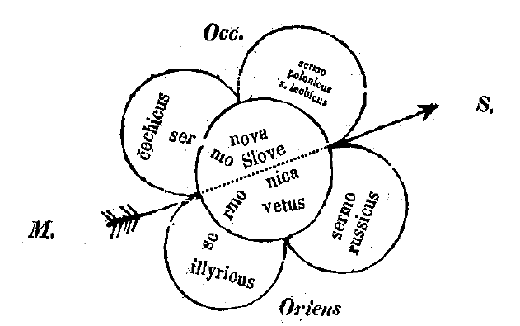

Alexander Maxwell (Victoria University of Wellington)
Disputing linguistic status beyond ‘Languages’ and ‘Dialects’:
Pavel Šafařík’s Taxonomy and Ľudovít Štúr’s Activism

In many parts of the world, disputes have arisen over the classification of linguistic varieties. Stereotypically, these disputes concern the status labels ‘language’ and ‘dialect’: one side declares the variety an independent language, the other denigrates it as a mere dialect. Nineteenth-century Slavic linguistic classification, however, proved more complicated. In 1842, Slovak savant Pavel Josef Šafařík posited a six-fold schema for classifying linguistic varieties: he divided the jazyk [‘language’] into mluwy, řeči, nářeči [‘dialects’], podřeči [‘subdialects’], and různořeči. This sixfold division enabled new forms of conflict over linguistic taxonomy. Indeed, before the decade was over, Slovak scholars debated the status of Slovak without invoking either the ‘language’ or the ‘dialect’: instead, they disagreed about the existence of a Czech řeč encompassing the Slovak.

Patrick Seán McCrea (Tulane University, New Orleans)
Politicizing Language: Centuries of Tradition à la française

The French Republic politically strived to realize its ideal of “one nation, one language” by imposing the French language and relegating anything else to the status of patois. Between World War I and II, subsequent French administrations largely achieved the revolutionaries’ political goal; however, by the 1960s, French regionalists readily questioned French national ideology by indicating that France’s historical provinces, and current regions, were in fact nations themselves with their own historical languages. Several historical linguists demonstrated that the purported Parisian dialect, Francien, which French national ideology claims to have become the French language by triumphing over the other medieval dialects, never truly existed. Regional militants attempted to either identify other falsehoods or to find new positions within French ideology; Occitan linguists focused on the importance of having language status, while denying this same status to French’s sisters, the Langues d’Oïl. Others claimed that the Langues d’Oïl, such as Champenois, were either dead or simply purported to become languages out of nowhere. It was every linguistic variety for itself. This paper explores the complicated and extensive political history involved in politicizing language in France.

Miriam Meyerhoff (Victoria University of Wellington)
“Linguistic autonyms and the politics
of documentation in Vanuatu“

Vanuatu is famously celebrated as having the highest level of linguistic diversity of any country in the world. This claim is generally justified in the light estimates of the number of languages that range from 80-something to as many as 140 languages. A range this extreme flags the fact that there are issues with language labelling in Vanuatu. Linguists who based their categorisations on structural criteria had been bringing the number down until a 2015 edited volume rolled the clock back, again giving weight to linguistic autonyms. Since villages often use a local autonym, thereby reifying a strong cultural value that identifies person with place, and place with langage, these autonyms may tell us little about the languages’ relatedness. This revalorisation of local perceptions has pushed the national language count back up. In this paper, I approach the phenomenon of linguistic categorisation and labelling from a sociolinguistic perspective. I will suggest that which autonyms are ratified by linguists (and which are not) reflects linguists’ agendas as well as those of the communities involved. I will discuss this in the context of my own fieldwork in northeast Santo. Documentation of the language known locally as Nkep has highlighted some of the regional politics associated with language labelling, and the prestige associated with the international, academic attention of having “your own linguist”.

Michal Schwarz (Masaryk University, Czechia)
“Mongol-oriented Taxons in Modern Science”

Interdisciplinary demands of modern science need to combine biology, linguistics and genetics. Mongols hold their taxonomic role in all these areas. Although now their widest extent regarding human race (Mongoloids) slowly lost its scientific value (but still it was not replaced completely), Mongol-oriented taxons are not endangered especially in linguistics (Mongolic languages) and appear in genetics or anthropology (Mongolian spot). This paper will focus on adequacy of these taxons including political sphere and some paradoxes: like importance and representation of Mongols on historical Chinese flag vs. possible claim that all Chinese are Mongoloids.

John Charles Smith (University of Oxford, St Catherine’s College)
“The Moldovan Language Controversy and the Manipulation of History”

In this paper, I shall demonstrate that the fact that Moldovan (or Moldavian), a term traditionally used to designate a group of Romanian dialects spoken not only in the Republic of Moldova but also in the contiguous area of north-eastern Romania, has been perceived in some quarters as a distinct language has an importance which transcends the controversies of the last 30 years. It can be traced back to abuses of historical linguistics perpetrated by Stalinism, which tended to stress the Slavonic element in the language and sometimes went so far as to claim that Moldovan was a Slavonic language, or a Romance-Slavonic contact language, distinct from Romanian. Not only were Slavonic elements in the language (resulting from a lengthy period of contact) highlighted and emphasized; many neologisms were borrowed from or calqued on Slavonic in a conscious attempt to demonstrate the hypothesis by ‘facts on the ground’. It is this fact that gives the Moldovan language controversy its broader significance.

James A. Walker (La Trobe University)
“A Variationist Perspective on Categorizing Linguistic Varieties”

Drawing a line between dialects and languages is notoriously difficult, because purely linguistic criteria do not provide a definitive answer and social and political criteria are applied inconsistently. I would argue that a major part of the difficulty lies in different definitions of ‘language’, not only colloquially but also within linguistics. In this paper I want to start to address the question of what we are studying when we study ‘language’. Drawing on work on ‘English’ spoken in different locales, I will examine the criteria that have been offered to argue for and against shared varieties: structural similarities, frequency of use, shared constraints and shared evaluation.

