Balkan Urban Experiences

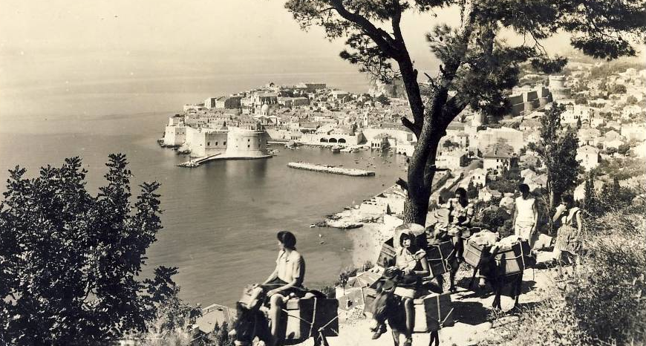

Though frequently neglected in European studies, the Balkans, and South-Eastern Europe generally, remains a region of great significance to European history and society. This interdisciplinary workshop seeks to examine urban experiences in this region. How has the political, economic, cultural, national, and religious life of the Balkans been affected by urban environments? Alternatively, how have Balkan cities been shaped by the unique experiences of its peoples? Papers examining any Balkan city are welcome, and comparative papers transcending national borders are particularly welcome.

The event will take place 18 August 2018 at the Kelburn Campus of Victoria University, Wellington, New Zealand. The event is free and open to the public. We regret that we have no money to support travel costs.

Send 100-word abstracts or queries to: Alexander Maxwell (alexander.maxwell@vuw.ac.nz)

