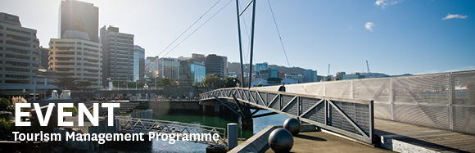
The Tourism Management Group, part of the School of Management, Victoria Business School,
invites you to attend the following seminar:
At the heart of society: Connecting through family tourism
Dr Heike Schänzel
Auckland University of Technology in Auckland
Monday 14th May

12.30 – 1.30pm

Boardroom, Level 12, Rutherford House
Pipitea Campus, Wellington

Children and families form the closest and most important emotional bond in humans. This relationship is what drives humanity and society, and positions the family at the centre of human activity. An increasing importance is placed on families spending quality time together because of the perception that parents are too busy and have less time. In fact, holidays are often the only time families spend together for an extended period without any distractions. Family travel is predicted to grow at a faster rate than all other forms of leisure, mainly because it represents a way to reunite families. The importance of social connectedness as fundamental to human life is usually lacking in tourism research. Instead, this presentation captures the diverse social dynamics and drivers of family tourism in its various forms of nuclear, extended and single-parent families as well as the emerging phenomenon of grandtravel.

About the presenter:
Dr Heike Schänzel is a Senior Lecturer and Programme Leader Post-graduate at Auckland University of Technology in Auckland, New Zealand. Her research interests include: tourist behaviour and experiences; families, children and adolescents in tourism; sociality in tourism; femininities and paternal masculinities in tourism research; innovative and qualitative research methodologies; critical theory development in tourism and hospitality. She is passionate about better understanding family fun (along with the avoidance of conflict) and the facilitation of sociality and meaningful experiences within the context of tourism and hospitality.

ALL WELCOME

Any queries please email: tourism@vuw.ac.nz

