Visual Culture and Conflict in Central and Eastern Europe

18 June 2018
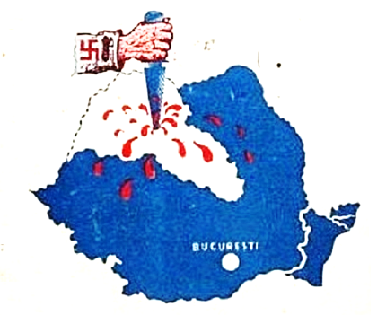

Centre for the History of Violence at the University of Newcastle (NSW), in cooperation with the Antipodean East European Study Group, Victoria University (NZ)

Room X803, NeW Space, Newcastle City Campus
Corner of Auckland St & King St, Newcastle NSW 2300

This symposium is free and open to the public.
Symposium Programme

9:30 Welcome and Registration

10:00 Panel 1: Caricatures and Cartoons

Euridice Charon-Cardona, Roger Markwick, Newcastle (NSW).
“Humour as a weapon: Soviet cartoons in the Great Patriotic War”.

Ludmilla A’Beckett, University of the Free State, South Africa
“The Russo-Ukrainian confrontation in cartoons and memes: Recontextualisation of culture-specific scenarios.”

11:00 Morning Tea 11:00 – 11:30

11:30 Panel 2: Anthropology and Cartography

Sacha Davis, University of Newcastle
“Ethnophotography and Nationalist Conflict in Habsburg Transylvania: The Collections of Emil Sigerus.”

Hans-Lukas Kieser, University of Newcastle
“Suppressing Islam and the Recent Past:
Atatürk’s National Revolution, Anthropologically Exalted.”

Alexander Maxwell, Victoria University of Wellington
“Austrian and American Popular Cartography
and the Frontiers of Ukraine, 1918-1919.”

1:00 Lunch 1:00

2:00 Panel 3: Symbols of Protest

Nela Milic, University of the Arts London
“Radical Artefacts.”

Denys Shestopalets, Monash University
“Wars on Symbols and Symbolic Wars in Ukraine, 2013-2018: Religion, Politics, and the Russian-Ukrainian Conflict.”

