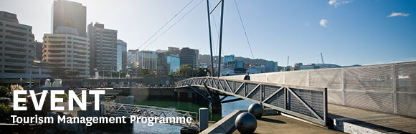

|  |  |  |  |  |  |  |  |  |  |  |
| --- | --- | --- | --- | --- | --- | --- | --- | --- | --- | --- |
| |  |  |  |  |  |  |  |  |  |  | | --- | --- | --- | --- | --- | --- | --- | --- | --- | --- | | |  | | --- | | The Tourism Management Group, part of the School of Management, Victoria Business School,  invites you to attend the following seminar: | |  | | **Love Festivals, Hate Waste:  How Festivals in New Zealand Minimise Waste** | | | **Presenters: Joany Grima & Leanne Nicholas** Wellington Institute of Technology (WelTec)  **Monday 30th April**  **12.30 – 1.30pm**  **Room 104, Level 1, Rutherford House**  **Pipitea Campus, Wellington**  Festivals are commonplace throughout New Zealand, and the number and frequency of festivals being staged is growing. Festivals occur in a range of settings, from urban streetscapes to remote rural environments, creating mini-communities for their duration. Festivals have the capacity to generate large volumes of waste, as most festivals feature food and drink vendors, from whom festival attendees purchase products predominately served in single-use packaging. This research project investigates the facilitators and barriers experienced by festival organisers in regards to implementing waste minimisation practices at their events, and explores waste minimisation practices at festivals from the perspective of the audience.  **About the presenters**:  Joany Grima has designed and delivered event management courses at Wellington Institute of Technology (WelTec) since 2010. Parallel to working in academia, Joany works as an international events manager. She has staged events in the tertiary, arts, government and not-for-profit sectors across five continents. Joany’s skills set is unique, built upon experience gained as a practitioner, educator, researcher and student.  Leanne Nicholas has developed and delivered a range of papers in tourism and food & beverage management on the Bachelor of Hospitality Management, Bachelor of Applied Management and Graduate Diplomas at WelTec since 2001. She also supervises third year degree student with industry research projects, and has extensive industry and consultancy experience in the hospitality sector.    ALL WELCOME | | |  | | |  |   Any queries please email: [tourism@vuw.ac.nz](mailto:tourism@vuw.ac.nz) |
|  |