Understanding ISIS/ISIL

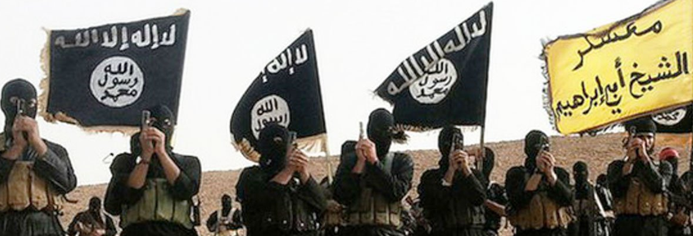

The emergence and success of the Islamic State of Iraq and the Levant, popularly known as ‘ISIS’ or ‘Daesh,’ has had tragic consequences for people living in Syria and Iraq, but also aroused consternation and alarm in Europe, America, and beyond. This interdisciplinary workshop attempts to look beyond popular hysteria to consider the significance of the Islamic State for the Middle East, for the Islamic world, for Russia, and/or for the Western powers.

The event will take place in the Wood Seminar Room (OK 406) on the Kelburn Campus of Victoria University. The event is free and open to the public

Abstracts

Hossein Aghapouri (Auckland University)
“ISIS and the Kurdish Question”

In the context of current massive changes as a result of ISIS/ISIL, the Kurdish question has brought back to the international arena. However, this time Kurds are not perceived as a trouble maker to the region, but the people who can deter Islamic fundamentalism and terrorism and embrace democracy, human rights and secularism. The current symbols, values and aspirations used by Kurdish nationalist actors during the ISIS crisis indicate a transformation in the Kurdish nationalism. By looking at the internal and external developments of Kurdistan in Iraq and Syria, this seminar/paper tries to explore whether these changes can be interpreted as the transformation of Kurdish nationalism from a purely Kurdish ethnic nationalism toward an ethno-civic model of Kurdistani identity in Kurdistan of Iraq and Kurdistan of Syria.

Alexander Maxwell (Victoria University)
“ISIS and the future of Arab Democracy”

The atrocities of the ISIS regime have caused some analysts to doubt the theoretical possibility of democratic government in the Arab world, or alternatively in the Islamic world. A long historical view of democratization, however, suggests that progress toward democratic government is steady. This paper contrasts ISIS propaganda with broader themes in recent Arab history, paying attention to its ideas of legitimacy. It suggests that the long-term prospects for Arab democracy are less gloomy than current events might suggest.

Abstracts

Hanlie Booysen (Victoria University)
“Are Islamists rational political actors?
Case study IS/ISIS”

IS has been labelled jihadi, salafi-jihadi, and takfiri in response to its extremist actions and a narrow interpretation of the Qur’an. While the influence of an ideology based on divine revelation cannot be discounted, such a single focus has skewed policies and analysis on how to deal with IS. In shifting the focus to IS’ political environment, I will argue that IS acted as a rational political actor in pursuing an Islamic state. In doing so, I will focus on IS’ utilisation of a) the political instability in Iraq and Syria; b) Sunni discontent in response to de-Ba‘thification in Iraq; and c) the Sunni-Shi‘a divide.

Ghassan Abu-Husein
“Dabiq: Understanding ISIS
through its Magazine.”

Ever since the ‘Islamic State’ declared the establishment of what it calls the "State of the Caliphate" on June 2014, it has deployed a strong media and propaganda machine, and has deftly used the Internet and social media to spread its message. ISIS launched its own media platforms under names that carry historical significance and/or were culled from religious texts, which reflect the military confrontation with the ‘Crusader Army’ in Dabiq (north of Aleppo). This study explores the media discourse of ISIS insofar as it belongs to an ideological organization, or as the group describes it, ‘jihadi media.’ To further explore the ISIS worldview, a content analysis of the organization's media discourse was conducted.

Conference schedule 11 March 2017

12:00 am – 1:00 pm
ISIS/ISIL in a Political Context

Hossein Aghapouri (Auckland University)
“ISIS and the Kurdish Question”
Alexander Maxwell (Victoria University, Wellington)
“ISIS and the future of Arab Democracy”

1:30 pm – 2:30 pm
ISIS/ISIL and their View of the World

Hanlie Booysen (Victoria University, Wellington)
“Are Islamists Rational Political Actors? Case study IS/ISIS”

Ghassan Abu-Husein (Middle East University, Amman)
“Dabiq: Understanding ISIS through its Magazine.”

Conference dinner

We will meet informally at 6:00 pm at the Marrakech Café
305 Evans Bay Parade, tel: 386-2884

