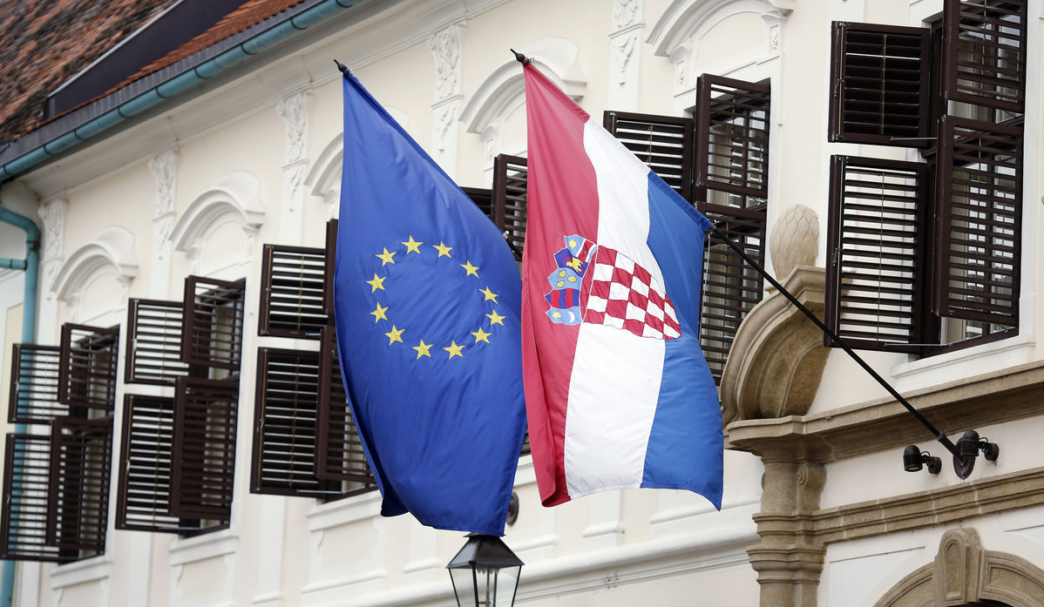
International Norms and East European Nations
Timothy Garton Ash notoriously claimed that the collapse of Communism in East-Central Europe brought forth “no fundamentally new ideas on the big questions of politics, law, and international relations.” All too often, scholars examine the region’s post-Communist “transition” by asking whether countries have or have not accepted or implemented institutions or values originally developed in Western Europe or North America. Eastern European nations, however, have their own aspirations rooted in domestic history and traditions. The garments of progress and democracy must be tailor-made: one size does not fit all. While local elites may also pursue illiberal policies under the banner of local peculiarity, they may rightly detect imperial self-interest sanctimoniously posing as progress or “international norms.” This workshop examines institutional, legal, ideological or cultural tensions between international actors and local elites. How do such tensions affect contemporary diplomacy in East Central Europe? How might they be resolved to mutual satisfaction?

5 February 2015, Victoria University, Wellington

We regret that we have no funds available to support overseas travel.
Due date for abstracts: 5 December 2014
To submit an abstract, or to ask a question, contact the organisers!

Alexander Maxwell alexander.maxwell (at) vuw.ac.nz
Wenwen Shen wenwen.shen (at) vuw.ac.nz

